WEB TECHNOLOGIES
LAB RECORD

WEEK-1
1.AIM :- Program to Build a simple personal portfolio page using HTML & CSS.
Description :- A personal portfolio webpage is a website that presents an individual's profile, skills, education, projects, and contact information. It serves as an online resume to showcase achievements and technical abilities. HTML is used to create the structure and content of the webpage, while CSS is used to design and style it with colors, layouts, and fonts. The portfolio provides easy navigation between different sections and offers a professional appearance. It is also designed to be responsive so that it works well on various devices. This project helps in learning the basics of web development using HTML and CSS.
HTML Code:-
<!DOCTYPE html>
<html lang="en">
<head>
<meta charset="UTF-8">
<meta name="viewport" content="width=device-width, initial-scale=1.0">
<title>Portfolio | Penta Venkata Sai Kranthi</title>
<link rel="stylesheet" href="styles.css">
<link href="https://fonts.googleapis.com/css2?family=Poppins:wght@400;600;800&display=swap" rel="stylesheet">
</head>
<body>

<nav>
<div class="nav-container">
<div class="logo-area">
<img src="anits-logo.jpg" alt="ANITS Logo" class="logo">
<img src="anits-banner.png" alt="ANITS Banner" class="banner-img">
</div>
<ul>
<li><a href="#home">Home</a></li>
<li><a href="#about">About</a></li>
<li><a href="#skills">Skills</a></li>
<li><a href="#projects">Projects</a></li>
<li><a href="#contact">Contact</a></li>
</ul>
</div>
</nav>
<header id="home" class="hero">
<div class="hero-content">
<img src="profile.jpg" alt="Penta Venkata Sai Kranthi" class="profile-img">
<h1>Penta Venkata Sai Kranthi</h1>
<p class="subtitle">III B.Tech IT | Anil Neerukonda Institute of Technology</p>
<p class="tagline">Aspiring Data Analyst passionate about data-driven decision making.</p>
<a href="#contact" class="btn">Get In Touch</a>
</div>
</header>

<section id="about">
<h2>About Me</h2>
<p>I am currently a 3rd-year Information Technology student at <strong>Anil Neerukonda Institute of Technology (ANITS)</strong>. I chose this branch because it provides the <strong>best strategic path</strong> for me to develop the technical foundation necessary to achieve my career milestones.</p>

<p>My ultimate core goals are becoming a successful <em>Data Analyst at Walmart</em>, achieving an excellent <em>GATE rank</em>, and securing a strong placement right from campus. My academic and technical interests heavily lean towards the <strong>non-coding/analytical domain</strong>, focusing on uncovering hidden insights within data structures.</p>

<p>When I am not studying, I enjoy refreshing my mind through my hobbies, which include <mark>dancing</mark>, <mark>reading books</mark>, and <mark>listening to songs</mark>.</p>
</section>

<section id="skills">
<h2>My Skills</h2>
<div class="skills-container">
<div class="skills-category">
<h3>Technical Skills</h3>
<div class="badges">
<span class="badge">HTML</span>
<span class="badge">CSS</span>
<span class="badge">JavaScript</span>
<span class="badge">Python</span>
<span class="badge">Java</span>
<span class="badge">SQL</span>
</div>
</div>
<div class="skills-category">
<h3>Soft Skills</h3>
<div class="badges">
<span class="badge soft">Communication</span>
<span class="badge soft">Adaptive</span>
<span class="badge soft">Time Management</span>
<span class="badge soft">Team Work</span>
</div>
</div>
</div>
</section>

<section id="projects">
<h2>Projects</h2>
<div class="projects-grid">
<div class="card">
<h3>Retail Sales Data Analysis Dashboard</h3>
<p>A concept project focusing on descriptive analytics using Python and SQL to identify buying trends, optimize stock levels, and predict consumer behavior in a retail environment.</p>
<a href="#" class="project-link">View Project Draft</a>
</div>
<div class="card">
<h3>Predictive Analytical Framework</h3>
<p>An ongoing data manipulation setup designed to process complex datasets, cleaning data and utilizing foundational analytical models geared towards corporate placement metrics.</p>
<a href="#" class="project-link">View Project Draft</a>
</div>
</div>
</section>

<section id="contact">
<h2>Contact Me</h2>
<form action="#" method="POST">
<div class="form-group">
<label for="name">Name</label>
<input type="text" id="name" name="name" placeholder="Your Full Name" required>
</div>

<div class="form-group">
<label for="email">Email</label>
<input type="email" id="email" name="email" placeholder="Your Email Address" required>
</div>

<div class="form-group">
<label for="phone">Phone</label>
<input type="tel" id="phone" name="phone" placeholder="Your Phone Number" required>
</div>

<div class="form-group">
<label for="message">Message</label>
<textarea id="message" name="message" rows="5" placeholder="Write your message here..." required></textarea>
</div>

<button type="submit" class="btn">Send Message</button>
</form>
</section>

<footer>
<div class="footer-content">
<p>&copy; 2026 Penta Venkata Sai Kranthi. All rights reserved.</p>
<address>
Email: <a href="mailto:pentakranthi6@gmail.com">pentakranthi6@gmail.com</a> |
Phone: <a href="tel:+917093228256">7093228256</a>
</address>
<div class="social-links">
<a href="https://www.linkedin.com/in/kranthi-penta-040b113b4" target="_blank">LinkedIn Profile</a>
</div>
</div>
</footer>

</body>
</html>

CSS Code:
:root {
--primary: #000814;
--secondary: #001D3D;
--card: #002855;
--accent: #0077B6;
--accent-hover: #00B4D8;
--background: #000814;
--text-main: #EAF4FF;
--text-muted: #B6C7D6;
--shadow: 0 10px 25px rgba(0,0,0,.6);
}

* {
margin: 0;
padding: 0;
box-sizing: border-box;
scroll-behavior: smooth;
}

body {
font-family: 'Poppins', sans-serif;
font-weight: 400;
background: var(--background);
color: var(--text-main);
line-height: 1.7;
}

nav {
position: sticky;
top: 0;
width: 100%;
background: var(--secondary);
z-index: 1000;
border-bottom: 1px solid #003566;
height: 90px;
}

.nav-container {
display: flex;
justify-content: space-between;
align-items: center;
max-width: 1400px;
margin: 0 auto;
padding: 0 20px;
height: 100%;
}

.logo-area {
display: flex;
align-items: center;
gap: 15px;
height: 100%;
}

.logo {
height: 75px;
width: auto;
object-fit: contain;
display: block;
}

.banner-img {
height: 50px;
width: auto;
object-fit: contain;
display: block;
}

nav ul {
display: flex;
flex-direction: row;
align-items: center;
list-style: none;
height: 100%;
margin: 0;
padding: 0;
}

nav ul li {
margin: 0 20px;
display: inline-block;
}

nav ul li a {
text-decoration: none;
color: var(--text-main);
font-weight: 600;
font-size: 1.1rem;
transition: all .3s ease;
white-space: nowrap;
}

nav ul li a:hover {
color: var(--accent-hover);
}<nav>
<div class="nav-container">
<div class="logo-area">
<img src="anits-logo.jpg" alt="ANITS Logo" class="logo">
<img src="anits-banner.png" alt="ANITS Banner" class="banner-img">
</div>
<ul>
<li><a href="#home">Home</a></li>
<li><a href="#about">About</a></li>
<li><a href="#skills">Skills</a></li>
<li><a href="#projects">Projects</a></li>
<li><a href="#contact">Contact</a></li>
</ul>
</div>
</nav>

nav ul li a:hover::after {
width: 100%;
}

section {
padding: 70px 10%;
}

h1, h2, h3 {
font-weight: 700;
}

h2 {
color: var(--accent-hover);
margin-bottom: 20px;
text-align: center;
}

#home {
text-align: center;
color: var(--text-main);
background: linear-gradient(135deg, #000814, #001D3D, #002855);
}

#home img {
width: 180px;
height: 180px;
border-radius: 50%;
border: 5px solid var(--accent-hover);
object-fit: cover;
margin-bottom: 20px;
animation: float 3s infinite ease-in-out;
box-shadow: 0 0 20px rgba(0, 180, 216, .4);
}

@keyframes float {
0% { transform: translateY(0); }
50% { transform: translateY(-10px); }
100% { transform: translateY(0); }
}

.skills {
display: flex;
justify-content: center;
gap: 30px;
flex-wrap: wrap;
}

.skills div {
background: var(--card);
padding: 25px;
border-radius: 15px;
width: 320px;
box-shadow: var(--shadow);
transition: all .3s ease;
border: 1px solid #003566;
}

.skills div:hover {
transform: translateY(-6px);
border-color: var(--accent);
}

.skills ul {
margin-top: 15px;
padding-left: 20px;
color: var(--text-muted);
}

.projects {
display: grid;
grid-template-columns: repeat(auto-fit, minmax(300px, 1fr));
gap: 30px;
}

.card {
background: var(--card);
padding: 25px;
border-radius: 15px;
box-shadow: var(--shadow);
transition: all .3s ease;
border: 1px solid #003566;
}

.card h3 {
color: var(--text-main);
}

.card p {
color: var(--text-muted);
}

.card:hover {
transform: translateY(-8px);
box-shadow: 0 15px 30px rgba(0, 119, 182, .35);
border-color: var(--accent);
}

.card a {
display: inline-block;
margin-top: 15px;
text-decoration: none;
background: #00509D;
color: white;
padding: 10px 18px;
border-radius: 6px;
font-weight: 600;
transition: all .3s ease;
}

.card a:hover {
background: #00B4D8;
color: white;
}

form {
max-width: 700px;
margin: auto;
background: var(--card);
padding: 30px;
border-radius: 15px;
box-shadow: var(--shadow);
border: 1px solid #003566;
}

label {
display: block;
margin-bottom: 5px;
font-weight: 600;
color: var(--text-main);
}

input, textarea {
width: 100%;
padding: 12px;
margin-bottom: 20px;
background: #001D3D;
border: 2px solid #003566;
border-radius: 8px;
color: var(--text-main);
font-family: 'Poppins', sans-serif;
}

input:focus, textarea:focus {
outline: none;
border-color: var(--accent-hover);
box-shadow: 0 0 8px rgba(0, 180, 216, .3);
}

button {
background: #00509D;
color: white;
font-weight: 700;
border: none;
padding: 12px 25px;
border-radius: 8px;
cursor: pointer;
transition: all .3s ease;
}

button:hover {
background: #00B4D8;
color: #000814;
transform: translateY(-3px);
}

footer {
background: #001D3D;
color: var(--text-muted);
text-align: center;
padding: 25px;
border-top: 1px solid #003566;
}

footer a {
color: var(--accent-hover);
text-decoration: none;
}

footer a:hover {
text-decoration: underline;
}

address {
margin-top: 15px;
font-style: normal;
}

@media(max-width: 768px) {
.nav-container {
flex-direction: column;
height: auto;
padding: 10px;
}

nav ul {
flex-direction: column;
align-items: center;
width: 100%;
}

nav ul li {
margin: 10px 0;
}

.skills {
flex-direction: column;
align-items: center;
}

.projects {
grid-template-columns: 1fr;
}

section {
padding: 50px 20px;
}

#home img {
width: 150px;
height: 150px;
}
}
Output:-
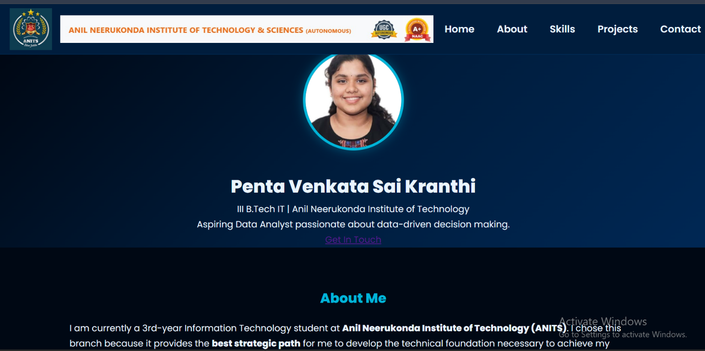

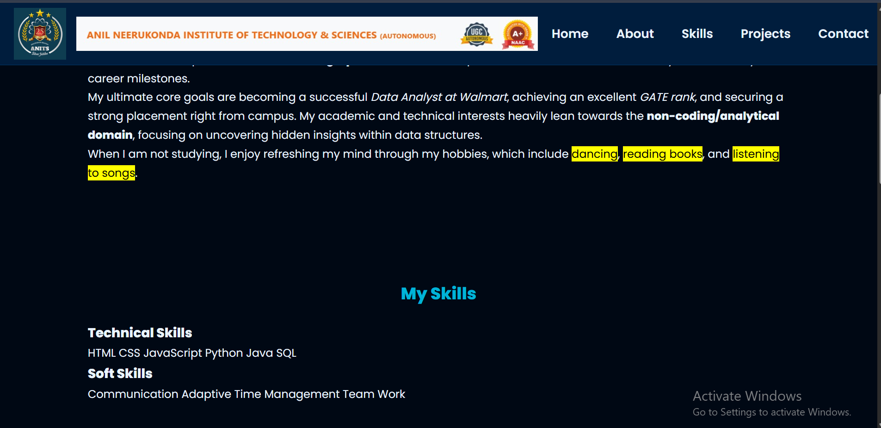
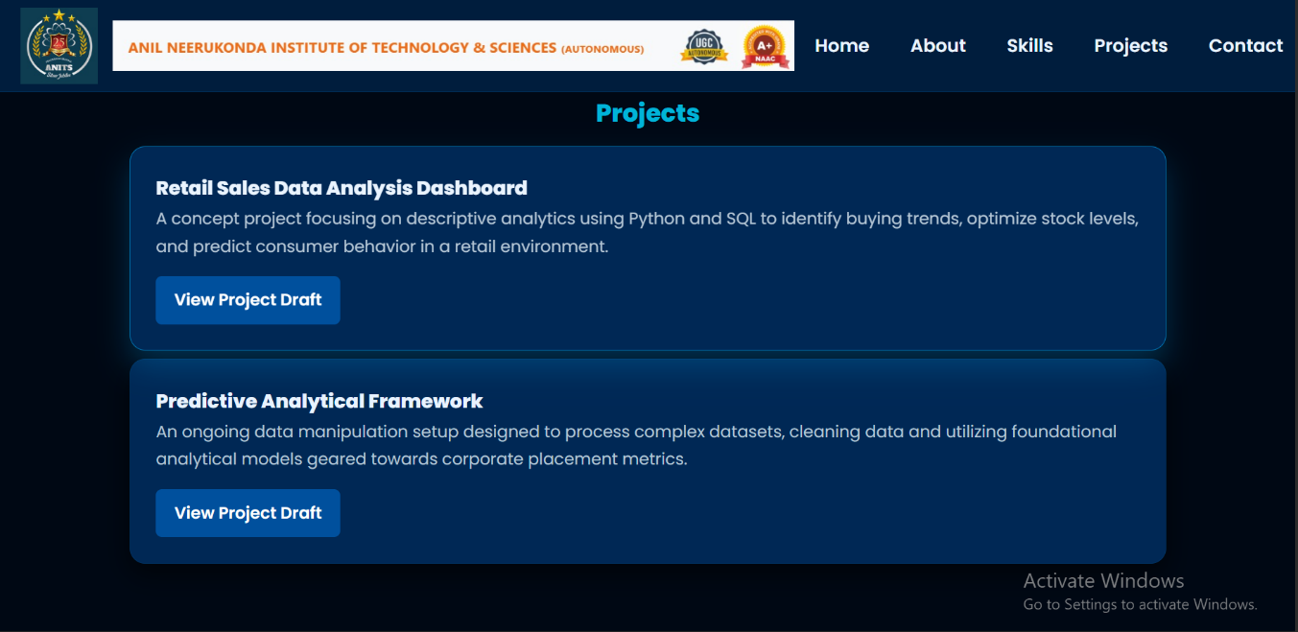
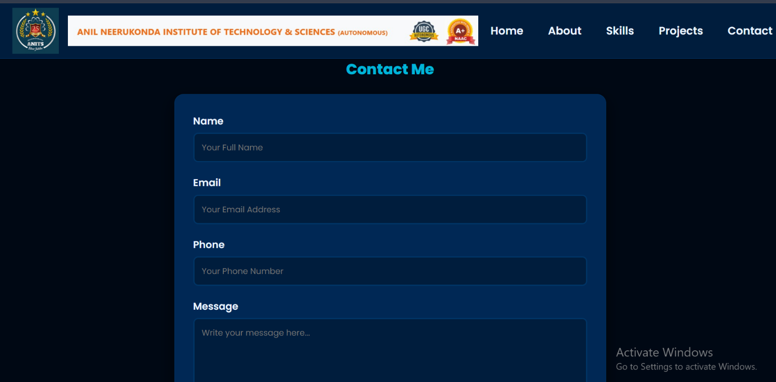
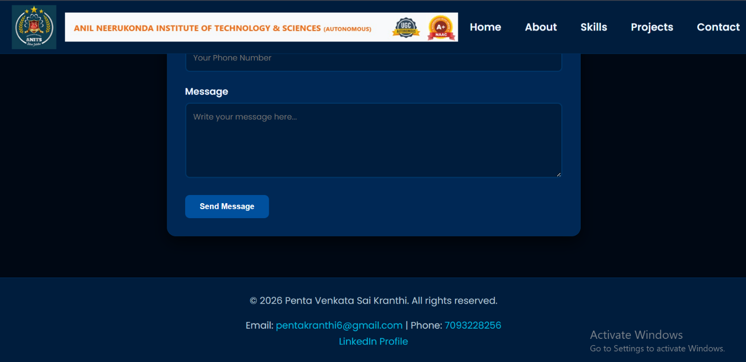
Outcome:
The portfolio webpage successfully displays personal information, skills, education, projects, and contact details with an attractive and responsive user interface.

WEEK-2
2.AIM :- Student Profile Web Page Using HTML and Bootstrap
Objective:-
Create a responsive Student Profile webpage using HTML5 and Bootstrap 5.
Requirements:-
1. Create a webpage with the title “Student Profile”.
2. Use Bootstrap’s Navbar at the top with links:
* Home
* About
* Contact
3. Add a Bootstrap Card in the center containing:
* Student Photo
* Name
* Roll Number
* Branch
* Email ID
4. Create a section displaying academic details using a Bootstrap Table:
* Subject Name
* Internal Marks
* External Marks
* Total Marks
5. Add a Bootstrap Button labeled “View Profile”.
6. Use Bootstrap grid system to make the page responsive.
7. Add a footer with:
* College Name
* Copyright Information
Expected Learning Outcomes
* Use HTML5 structural elements.
* Integrate Bootstrap via CDN.
* Create responsive layouts using Bootstrap Grid.
* Use Bootstrap components such as Navbar, Card, Table, and Buttons.
* Design a simple professional webpage.
Description:-
A Student Profile Web Page is a responsive web application that displays a student's personal and academic information. HTML5 is used to create the webpage structure, and Bootstrap 5 is used to design a responsive and attractive interface. The webpage includes a navigation bar, student profile card, academic details table, and a "View Profile" button. This project helps in understanding Bootstrap components, the grid system, and responsive web design.
HTML Code:-
<!DOCTYPE html>
<html lang="en">

<head>

<meta charset="UTF-8">

<meta name="viewport" content="width=device-width, initial-scale=1.0">

<title>Student Profile</title>

<link href="https://cdn.jsdelivr.net/npm/bootstrap@5.3.3/dist/css/bootstrap.min.css" rel="stylesheet">

<link rel="stylesheet" href="style.css">

</head>

<body>

<nav class="navbar navbar-expand-lg navbar-dark">

<div class="container">

<a class="navbar-brand" href="#">Student Profile</a>

<button class="navbar-toggler" type="button" data-bs-toggle="collapse"
data-bs-target="#navbarNav">

<span class="navbar-toggler-icon"></span>

</button>

<div class="collapse navbar-collapse" id="navbarNav">

<ul class="navbar-nav ms-auto">

<li class="nav-item">
<a class="nav-link active" href="#">Home</a>
</li>

<li class="nav-item">
<a class="nav-link" href="#about">About</a>
</li>

<li class="nav-item">
<a class="nav-link" href="#contact">Contact</a>
</li>

</ul>

</div>

</div>

</nav>

<div class="container">

<div class="row justify-content-center">

<div class="col-lg-8">

<div class="card profile-card">

<div class="profile-header">

<h2>Student Profile</h2>

</div>

<div class="card-body">

<img src="profile.jpg" alt="Student Photo" class="profile-image">

<h3 class="mt-3">Penta Venkata Sai Kranthi</h3>

<p><strong>Roll Number:</strong> 22A91A12XX</p>

<p><strong>Branch:</strong> Information Technology</p>

<p><strong>Email:</strong> pentakranthi6@gmail.com</p>

<a href="#" class="btn btn-profile mt-2">
View Profile
</a>

</div>

</div>

</div>

</div>

<div class="row table-section">

<div class="col-12">

<div class="card p-4">

<h3 class="text-center mb-4" id="about">
Academic Details
</h3>

<div class="table-responsive">

<table class="table table-bordered table-hover text-center">

<thead class="table-dark">

<tr>

<th>Subject Name</th>
<th>Internal Marks</th>
<th>External Marks</th>
<th>Total Marks</th>

</tr>

</thead>

<tbody>

<tr>
<td>HTML & CSS</td>
<td>28</td>
<td>60</td>
<td>88</td>
</tr>

<tr>
<td>Java Programming</td>
<td>27</td>
<td>58</td>
<td>85</td>
</tr>

<tr>
<td>Python Programming</td>
<td>29</td>
<td>61</td>
<td>90</td>
</tr>

<tr>
<td>Database Management Systems</td>
<td>26</td>
<td>59</td>
<td>85</td>
</tr>

</tbody>

</table>

</div>

</div>

</div>

</div>

<div class="row mt-5" id="contact">

<div class="col-md-6 mx-auto">

<div class="card p-4">

<h3 class="text-center mb-3">Contact</h3>

<p><strong>Email:</strong> pentakranthi6@gmail.com</p>

<p><strong>Phone:</strong> 7093228256</p>

<p><strong>College:</strong> Anil Neerukonda Institute of Technology and Sciences</p>

</div>

</div>

</div>

</div>

<footer>

<p>Anil Neerukonda Institute of Technology and Sciences</p>

<p>© 2026 Penta Venkata Sai Kranthi. All Rights Reserved.</p>

</footer>

<script src="https://cdn.jsdelivr.net/npm/bootstrap@5.3.3/dist/js/bootstrap.bundle.min.js"></script>

</body>

</html>
CSS Code:
body {
background: linear-gradient(to right, #0d1b2a, #1b263b, #415a77);
font-family: Arial, sans-serif;
}

.navbar {
background-color: #0d1b2a;
}

.profile-card {
margin-top: 50px;
border-radius: 15px;
overflow: hidden;
box-shadow: 0 8px 20px rgba(0, 0, 0, 0.3);
}

.profile-header {
background-color: #1b263b;
color: white;
padding: 20px;
text-align: center;
}

.profile-image {
width: 170px;
height: 170px;
border-radius: 50%;
border: 5px solid white;
object-fit: cover;
margin-top: -85px;
background-color: white;
}

.card-body {
text-align: center;
padding: 30px;
}

.table-section {
margin-top: 40px;
}

.btn-profile {
background-color: #0d6efd;
color: white;
}

.btn-profile:hover {
background-color: #084298;
color: white;
}

footer {
margin-top: 50px;
background-color: #0d1b2a;
color: white;
text-align: center;
padding: 15px;
}
Output:-
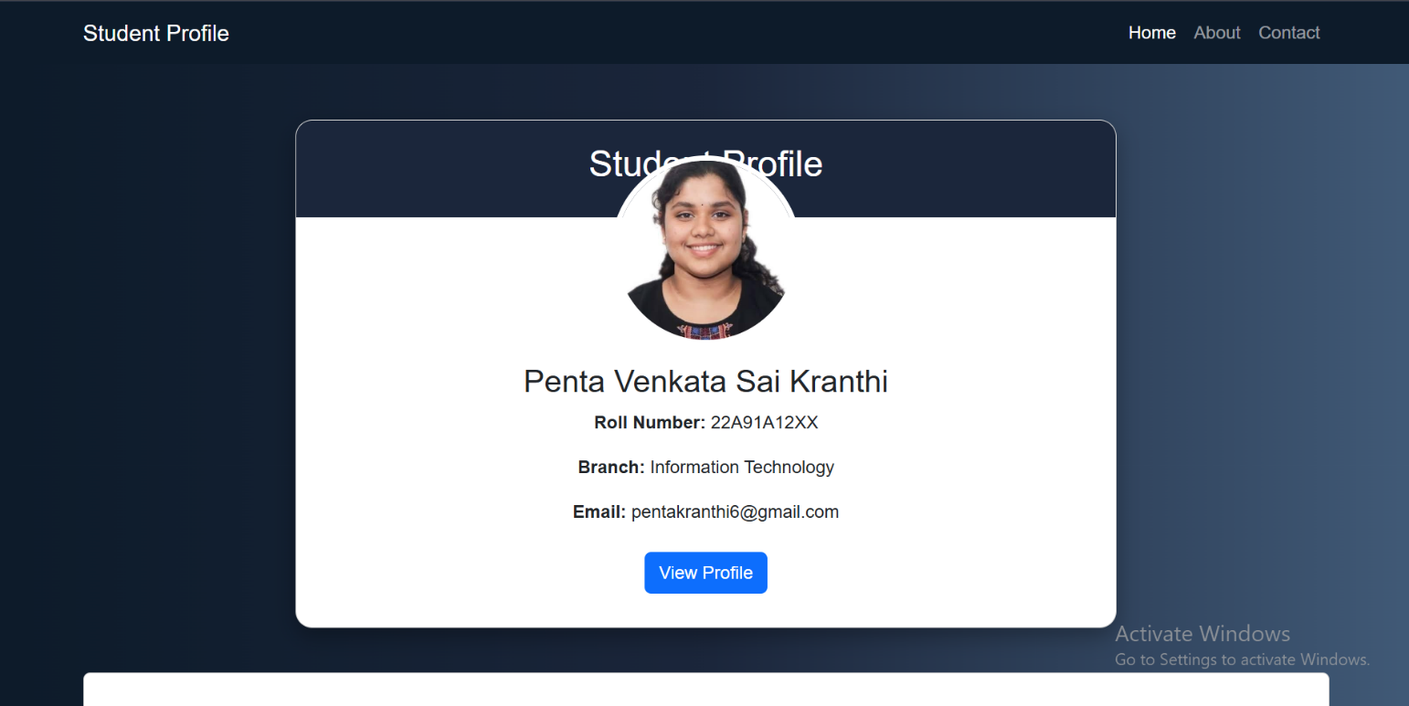

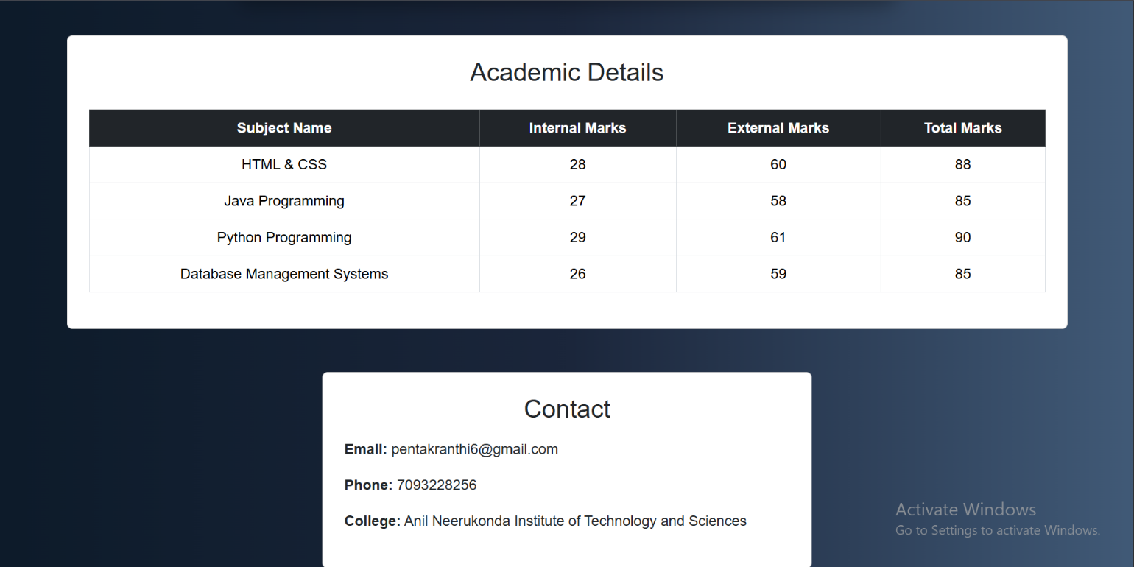

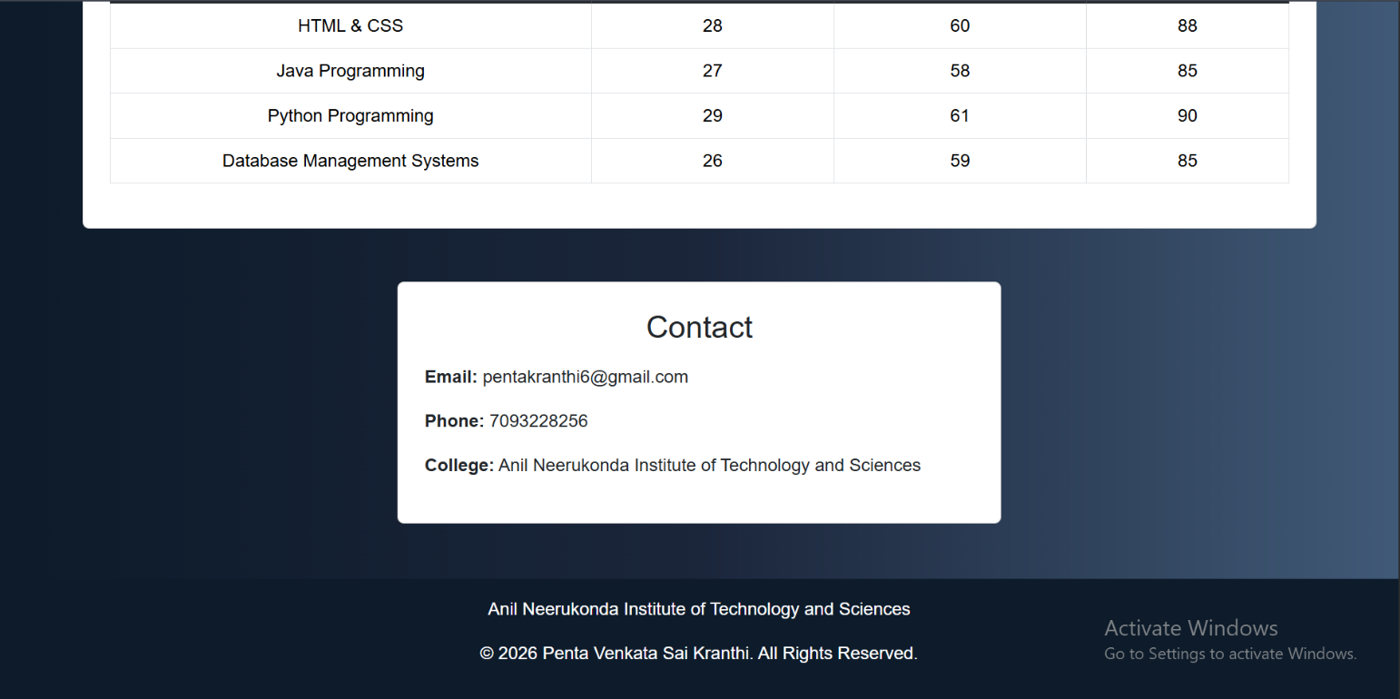

Outcome:-
The Student Profile Web Page was successfully created using HTML5 and Bootstrap 5. The webpage displays student information and academic marks in a responsive and well-structured layout using Bootstrap components such as Navbar, Card, Table, Button, and Grid System. This project improved understanding of HTML5 structure, Bootstrap integration, responsive web design, and the use of Bootstrap components to create professional webpages.

WEEK-3
Task 1: Student Registration Form with Validation
Objective:-
Design a responsive student registration form using HTML and CSS and validate the input
fields using JavaScript.
Requirements:-
Create a registration form containing the following fields:
- Full Name
- Roll Number
- Email ID
- Mobile Number
- Password
- Confirm Password
- Gender
- Department
- Date of Birth
- Submit Button
Validation Rules:-
- Full Name should not be empty.
- Roll Number must contain only letters and numbers.
- Email must be in a valid format.
- Mobile Number must contain exactly 10 digits.
- Password must be at least 8 characters long.
- Password and Confirm Password must match.
- Gender must be selected.
- Department must be selected.
- Date of Birth should not be empty.
- Display appropriate error messages.
- Show a success message after successful validation.
Description:-
A Student Registration Form is a web application used to collect and validate student information such as personal and academic details. HTML is used to create the structure of the form, while CSS is used to design an attractive and responsive user interface. JavaScript is used to perform client-side validation to ensure that all input fields contain valid data before submission. The form validates the full name, roll number, email, mobile number, password, gender, department, and date of birth according to the specified rules. Appropriate error messages are displayed for invalid inputs, and a success message is shown after successful validation. This project helps in understanding HTML forms, CSS styling, JavaScript validation, and event handling.
HTML Code:-
<!DOCTYPE html>
<html lang="en">

<head>

<meta charset="UTF-8">

<meta name="viewport" content="width=device-width, initial-scale=1.0">

<title>Student Registration Form</title>

<link rel="stylesheet" href="style.css">

</head>

<body>

<div class="container">

<h1>Student Registration Form</h1>

<form id="registrationForm">

<div class="input-group">

<label for="fullname">Full Name</label>

<input type="text" id="fullname">

<small class="error"></small>

</div>

<div class="input-group">

<label for="rollnumber">Roll Number</label>

<input type="text" id="rollnumber">

<small class="error"></small>

</div>

<div class="input-group">

<label for="email">Email ID</label>

<input type="email" id="email">

<small class="error"></small>

</div>

<div class="input-group">

<label for="mobile">Mobile Number</label>

<input type="text" id="mobile">

<small class="error"></small>

</div>

<div class="input-group">

<label for="password">Password</label>

<input type="password" id="password">

<small class="error"></small>

</div>

<div class="input-group">

<label for="confirmPassword">Confirm Password</label>

<input type="password" id="confirmPassword">

<small class="error"></small>

</div>

<div class="input-group">

<label>Gender</label>

<div class="gender">

<input type="radio" name="gender" value="Male"> Male

<input type="radio" name="gender" value="Female"> Female

<input type="radio" name="gender" value="Other"> Other

</div>

<small class="error"></small>

</div>

<div class="input-group">

<label for="department">Department</label>

<select id="department">

<option value="">Select Department</option>

<option value="IT">IT</option>

<option value="CSE">CSE</option>

<option value="ECE">ECE</option>

<option value="EEE">EEE</option>

<option value="MECH">MECH</option>

</select>

<small class="error"></small>

</div>

<div class="input-group">

<label for="dob">Date of Birth</label>

<input type="date" id="dob">

<small class="error"></small>

</div>

<button type="submit">Submit</button>

<p id="successMessage"></p>

</form>

</div>

<script src="script.js"></script>

</body>

</html>

CSS Code:
*{
margin:0;
padding:0;
box-sizing:border-box;
font-family:Arial, sans-serif;
}

body{
background:linear-gradient(135deg,#0f172a,#1e3a8a);
min-height:100vh;
display:flex;
justify-content:center;
align-items:center;
padding:20px;
}

.container{
width:100%;
max-width:500px;
background:white;
padding:30px;
border-radius:12px;
box-shadow:0 10px 25px rgba(0,0,0,0.3);
}

h1{
text-align:center;
margin-bottom:20px;
color:#1e3a8a;
}

.input-group{
margin-bottom:15px;
}

label{
display:block;
margin-bottom:6px;
font-weight:bold;
}

input,
select{
width:100%;
padding:10px;
border:1px solid #ccc;
border-radius:6px;
font-size:16px;
}

.gender{
display:flex;
gap:15px;
margin-top:5px;
}

button{
width:100%;
padding:12px;
border:none;
border-radius:6px;
background:#1e3a8a;
color:white;
font-size:16px;
cursor:pointer;
}

button:hover{
background:#2563eb;
}

.error{
color:red;
font-size:14px;
}

#successMessage{
text-align:center;
color:green;
margin-top:15px;
font-weight:bold;
}
JavaScript Code:-
const form = document.getElementById("registrationForm");

form.addEventListener("submit", function(event){

event.preventDefault();

let valid = true;

document.querySelectorAll(".error").forEach(error => {
error.textContent = "";
});

document.getElementById("successMessage").textContent = "";

const fullname = document.getElementById("fullname").value.trim();

const rollnumber = document.getElementById("rollnumber").value.trim();

const email = document.getElementById("email").value.trim();

const mobile = document.getElementById("mobile").value.trim();

const password = document.getElementById("password").value;

const confirmPassword = document.getElementById("confirmPassword").value;

const department = document.getElementById("department").value;

const dob = document.getElementById("dob").value;

const gender = document.querySelector(
'input[name="gender"]:checked'
);

if(fullname === ""){

showError("fullname", "Full Name is required");

valid = false;
}

const rollPattern = /^[a-zA-Z0-9]+$/;

if(!rollPattern.test(rollnumber)){

showError("rollnumber", "Only letters and numbers are allowed");

valid = false;
}

const emailPattern = /^[^ ]+@[^ ]+\.[a-z]{2,3}$/;

if(!emailPattern.test(email)){

showError("email", "Enter a valid email");

valid = false;
}

const mobilePattern = /^[0-9]{10}$/;

if(!mobilePattern.test(mobile)){

showError("mobile", "Mobile number must contain 10 digits");

valid = false;
}

if(password.length < 8){

showError("password", "Password must be at least 8 characters");

valid = false;
}

if(password !== confirmPassword){

showError("confirmPassword", "Passwords do not match");

valid = false;
}

if(!gender){

document.querySelectorAll(".error")[6].textContent =
"Please select gender";

valid = false;
}

if(department === ""){

showError("department", "Select department");

valid = false;
}

if(dob === ""){

showError("dob", "Select date of birth");

valid = false;
}

if(valid){

document.getElementById("successMessage").textContent =
"Registration Successful!";
}

});

function showError(id, message){

const field = document.getElementById(id);

field.nextElementSibling.textContent = message;
}
Output:-
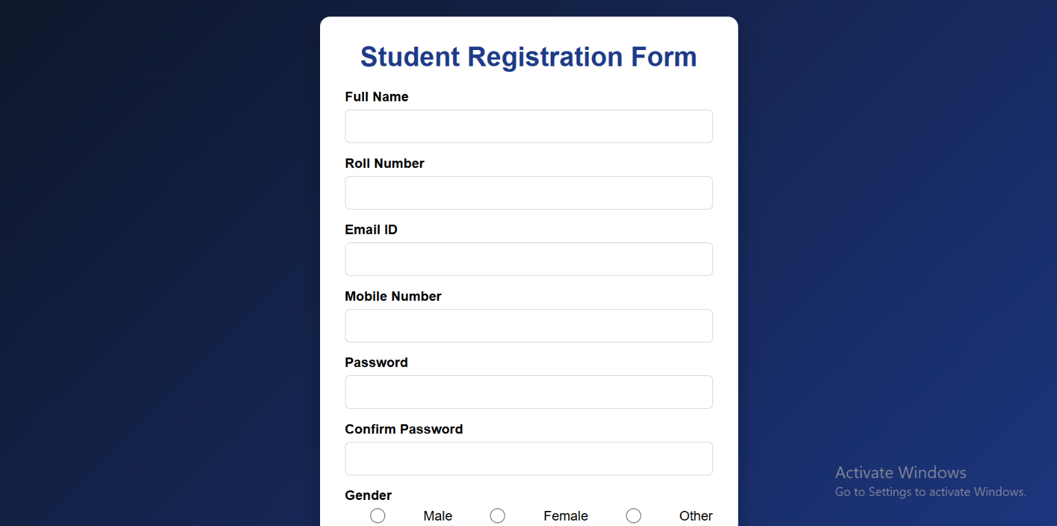

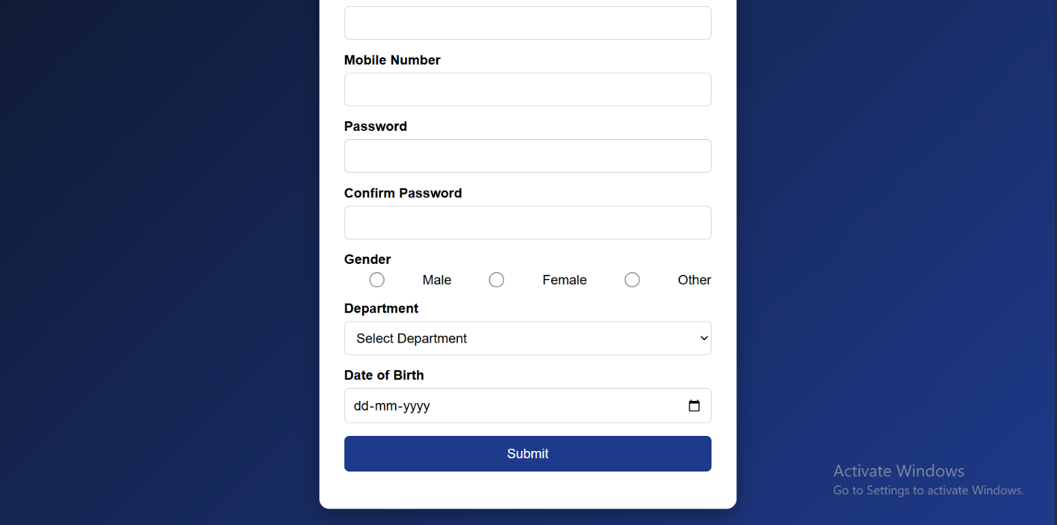
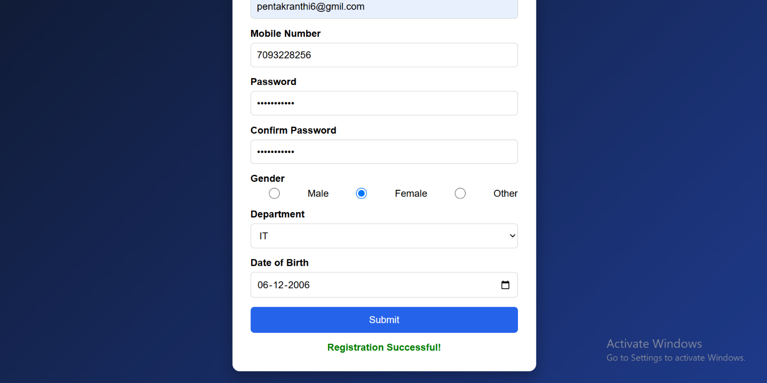

Outcome:-
The Student Registration Form was successfully developed using HTML, CSS, and JavaScript. The form accepts student details through a responsive user interface and validates all input fields based on the specified conditions. Appropriate error messages are displayed for invalid inputs, and a success message is shown after successful validation. This project improved understanding of HTML forms, CSS styling, JavaScript form validation, and client-side event handling.

Task 2: Personal Portfolio Website with Contact Form Validation
Objective:-
Develop a responsive personal portfolio website using HTML, CSS, and JavaScript.
Website Sections:-
- Home
- About Me
- Skills
- Education
- Projects
- Contact
Portfolio Requirements:-
- Navigation bar
- Profile image
- Skills displayed using cards or progress bars
- Project section with at least three projects
- Footer with social media links
Contact Form:-
Include the following fields:
- Name
- Email
- Subject
- Message
- Submit Button
Validation Rules:-
- Name cannot be empty.
- Email must be valid.
- Subject should contain at least 5 characters.
- Message should contain at least 20 characters.
- Display error messages beside each field.
- Show a &quot;Message Sent Successfully&quot; alert after successful validation.

Description:- A Personal Portfolio Website is a responsive web application that showcases an individual's profile, skills, education, projects, and contact information. It is developed using HTML for structure, CSS for styling, and JavaScript for contact form validation. The website includes multiple sections with a user-friendly navigation bar and responsive design. This project helps in learning web page design, responsive layouts, and client-side form validation.
HTML Code:-
<!DOCTYPE html>
<html lang="en">
<head>
<meta charset="UTF-8">
<meta name="viewport" content="width=device-width, initial-scale=1.0">
<title>Ejjipurapu Kavya | Portfolio</title>
<!-- CSS -->
<link rel="stylesheet" href="style.css">
<!-- Font Awesome -->
<link rel="stylesheet"
href="https://cdnjs.cloudflare.com/ajax/libs/font-awesome/6.6.0/css/all.min.css">
<!-- Google Fonts -->
<link>
href="https://fonts.googleapis.com/css2?family=Poppins:wght@300;400;500;600;700&display=swap"
rel="stylesheet">
</head>
<body>
<!-- ================= NAVBAR ================= -->
<header>
<nav class="navbar">
<div class="logo">
<span>WELCOME</span>
</div>
<ul class="nav-links">
<li><a href="#home">Home</a></li>
<li><a href="#about">About</a></li>
<li><a href="#skills">Skills</a></li>
<li><a href="#education">Education</a></li>
<li><a href="#projects">Projects</a></li>
<li><a href="#contact">Contact</a></li>
</ul>
</nav>
</header>
<!-- ================= HOME ================= -->
<section class="home" id="home">
<div class="home-content">
<h3>Hello, It's Me 👋</h3>
<h1>Ejjipurapu Kavya</h1>
<h2>
I'm
<span id="typing"></span>
</h2>
<p>
Passionate Information Technology student with a strong interest
in Artificial Intelligence, Python Programming,
and Web Development. I enjoy solving real-world
problems through innovative projects and continuously expanding
my technical knowledge.
</p>
<div class="home-buttons">
<a href="#contact" class="btn">
Contact Me
</a>
<a href="#" class="btn btn2">
Download Resume
</a>
</div>
<div class="social-icons">
<a href="#">
<i class="fab fa-github"></i>
</a>
<a href="#">
<i class="fab fa-linkedin"></i>
</a>
<a href="mailto:yourmail@example.com">
<i class="fas fa-envelope"></i>
</a>
</div>
</div>
<div class="home-image">
<img src="profile.jpg" alt="Ejjipurapu Kavya">
</div>
</section>
<!-- ================= ABOUT ================= -->
<section id="about">
<h2 class="heading">
About <span>Me</span>
</h2>
<div class="about-container">
<div class="about-text">
<h3>AI & ML Enthusiast</h3>
<p>
I am Ejjipurapu Kavya, a Third-Year B.Tech Information
Technology student at Anil Neerukonda Institute of Technology
and Sciences (ANITS).
I am passionate about Artificial Intelligence,
Machine Learning, Data Science, Python Programming
and Front-End Web Development.
I actively participate in internships,
certification programs and project development
to improve my technical and problem-solving skills.
My goal is to become a successful AI & Machine
Learning Engineer and build innovative solutions
that create a positive impact.
</p>
</div>
</div>
</section
<!-- ================= SKILLS ================= -->
<section id="skills">
<h2 class="heading">
My <span>Skills</span>
</h2>
</div>
<div class="skill">
<p>Python <span>65%</span></p>
<div class="progress">
<div class="python"></div>
</div>
</div>
<div class="skill">
<p>Java <span>50%</span></p>
<div class="progress">
<div class="java"></div>
</div>
</div>
</div>
<div class="skill">
<p>C Programming <span>48%</span></p>
<div class="progress">
<div class="c"></div>
</div>
</div>
<div class="skill">
<p>C++ <span>63%</span></p>
<div class="progress">
<div class="cpp"></div>
</div>
<div class="skill">
<p>Git & GitHub <span>30%</span></p
<div class="progress">
<div class="git"></div>
</div>
</div>
</div>
</section>
<!-- ========= CONTINUE IN PART 2 ========= -->
<!-- ================= EDUCATION ================= -->
<section id="education">
<h2 class="heading">
My <span>Education</span>
</h2>
<div class="education-container">
<div class="education-card">
<i class="fas fa-graduation-cap"></i>
<h3>B.Tech - Information Technology</h3>
<p>
<strong>College:</strong><br>
Anil Neerukonda Institute of Technology and Sciences (ANITS)
</p>
<p>
<strong>Year:</strong> III B.Tech
</p>
<p>
<strong>CGPA:</strong> 8.97 / 10
</p>
</div>
</div
</section>
<!-- ================= PROJECTS ================= -->
<section id="projects">
<h2 class="heading">
My <span>Projects</span>
</h2>
<div class="project-container">
<!-- Project 1 -->
<div class="project-card">
<div class="project-content">
<h3>OptiCrop</h3>
<p>
AI-based Crop Recommendation System that predicts the
best crop using soil nutrients and weather conditions.
</p>
<h4>Technologies</h4>
<p>Python • Machine Learning • Flask • Scikit-Learn</p>
<div class="project-buttons">
<a href="#" class="btn">GitHub</a>
<a href="#" class="btn btn2">Demo</a>
</div>
</div>
</div>
<!-- Project 2 -->
<div class="project-card">

<div class="project-content">
<h3>Smart Hostel Management System</h3>
<p>
Java desktop application for hostel room allocation,
fee management and student record management.
</p>
<h4>Technologies</h4>
<p>Java • JDBC • MySQL • NetBeans</p>
<div class="project-buttons">
<a href="#" class="btn">GitHub</a>
<a href="#" class="btn btn2">Demo</a>
</div>
</div>
</div>
<!-- Project 3 -->
<div class="project-card">
<div class="project-content">
<h3>Real-Time Incident Monitoring Dashboard</h3>
<p>
IoT-based accident monitoring dashboard that provides
real-time emergency notifications.
</p>
<h4>Technologies</h4>
<p>IoT • Dashboard • Sensors • Data Visualization</p>
<div class="project-buttons">
<a href="#" class="btn">GitHub</a>
<a href="#" class="btn btn2">Demo</a>
</div>
</div>
</div>
</div>
</section>
<!-- ================= CONTACT ================= -->
<section id="contact">
<h2 class="heading">
Contact <span>Me</span>
</h2>
<form id="contactForm">
<div class="input-box">
<input
type="text"
id="name"
placeholder="Your Name">
<small id="nameError"></small>
</div>
<div class="input-box">
<input
type="email"
id="email"
placeholder="Your Email">
<small id="emailError"></small>
</div>
<div class="input-box">
<input
type="text"
id="subject"
placeholder="Subject">
<small id="subjectError"></small>
</div>
<div class="input-box">
<textarea
id="message"
rows="7"
placeholder="Your Message"></textarea>
<small id="messageError"></small>
</div>
<button
type="submit"
class="btn">
Send Message
</button>
</form>
</section>
<!-- ================= FOOTER ================= -->
<footer>
<h2>Ejjipurapu Kavya</h2>
<p>
B.Tech Information Technology Student <br>
AI & Machine Learning Enthusiast
</p>
<div class="footer-icons">
<a href="#">
<i class="fab fa-github"></i>
</a>
<a href="#">
<i class="fab fa-linkedin"></i>
</a>
<a href="mailto:yourmail@example.com">
<i class="fas fa-envelope"></i>
</a>
</div>
<p class="copyright">
© 2026 Ejjipurapu Kavya | All Rights Reserved
</p>
</footer>
<!-- ================= JAVASCRIPT ================= -->
<script src="script.js"></script>
</body>
</html>

CSS Code:-
@import url('https://fonts.googleapis.com/css2?family=Poppins:wght@300;400;500;600;700&display=swap');

*{
margin:0;
padding:0;
box-sizing:border-box;
font-family:'Poppins',sans-serif;
scroll-behavior:smooth;
}

body{
background:linear-gradient(135deg,#eef6ff,#d8e8ff,#ffffff);
background-size:400% 400%;
animation:bgAnimation 15s ease infinite;
color:#222;
overflow-x:hidden;
}

@keyframes bgAnimation{
0%{
background-position:0% 50%;
}
50%{
background-position:100% 50%;
}
100%{
background-position:0% 50%;
}
}

section{
padding:90px 10%;
}

.heading{
text-align:center;
font-size:40px;
margin-bottom:60px;
color:#1e3a8a;
}

.heading span{
color:#00a8ff;
}

a{
text-decoration:none;
}

img{
max-width:100%;
}

header{
position:fixed;
top:0;
left:0;
width:100%;
z-index:1000;
background:rgba(255,255,255,.15);
backdrop-filter:blur(12px);
box-shadow:0 8px 25px rgba(0,0,0,.08);
}

.navbar{
display:flex;
justify-content:space-between;
align-items:center;
padding:18px 10%;
}

.logo{
font-size:30px;
font-weight:700;
color:#1e3a8a;
letter-spacing:2px;
}

.logo span{
color:#00a8ff;
}

.nav-links{
display:flex;
list-style:none;
}

.nav-links li{
margin-left:30px;
}

.nav-links li a{
color:#222;
font-weight:500;
transition:.3s;
}

.nav-links li a:hover,
.nav-links li a.active{
color:#00a8ff;
}

.home{
min-height:100vh;
display:flex;
justify-content:space-between;
align-items:center;
gap:50px;
flex-wrap:wrap;
}

.home-content{
flex:1;
}

.home-content h3{
font-size:30px;
color:#1e3a8a;
}

.home-content h1{
font-size:60px;
margin:12px 0;
color:#111;
}

.home-content h2{
font-size:35px;
margin-bottom:20px;
}

#typing{
color:#00a8ff;
font-weight:700;
}

.home-content p{
font-size:18px;
line-height:1.8;
max-width:650px;
margin-bottom:35px;
}

.home-buttons{
display:flex;
gap:20px;
margin-bottom:30px;
}

.btn{
background:#1e3a8a;
color:white;
padding:14px 30px;
border-radius:40px;
transition:.4s;
box-shadow:0 10px 25px rgba(30,58,138,.3);
border:none;
cursor:pointer;
}

.btn:hover{
background:#00a8ff;
transform:translateY(-6px);
}

.btn2{
background:transparent;
color:#1e3a8a;
border:2px solid #1e3a8a;
}

.btn2:hover{
color:white;
}

.social-icons{
display:flex;
gap:18px;
}

.social-icons a{
width:50px;
height:50px;
display:flex;
justify-content:center;
align-items:center;
border-radius:50%;
background:white;
color:#1e3a8a;
font-size:22px;
transition:.4s;
box-shadow:0 10px 25px rgba(0,0,0,.1);
}

.social-icons a:hover{
background:#00a8ff;
color:white;
transform:translateY(-8px) rotate(360deg);
}

.home-image{
flex:1;
display:flex;
justify-content:center;
}

.home-image img{
width:360px;
height:360px;
border-radius:50%;
object-fit:cover;
border:8px solid white;
box-shadow:0 25px 50px rgba(0,0,0,.18);
animation:floatImage 4s ease-in-out infinite;
}

@keyframes floatImage{
0%{
transform:translateY(0);
}

50%{
transform:translateY(-18px);
}

100%{
transform:translateY(0);
}
}

.about-container{
display:flex;
justify-content:center;
align-items:center;
}

.about-text{
max-width:900px;
background:rgba(255,255,255,.55);
backdrop-filter:blur(10px);
padding:35px;
border-radius:20px;
box-shadow:0 20px 45px rgba(0,0,0,.08);
}

.about-text h3{
font-size:30px;
color:#1e3a8a;
margin-bottom:20px;
}

.about-text p{
font-size:17px;
line-height:1.9;
text-align:justify;
}

#skills{
background:linear-gradient(135deg,#f5f9ff,#eef5ff);
}

.skills{
max-width:900px;
margin:auto;
}
.skill{
margin-bottom:28px;
}

.skill p{
display:flex;
justify-content:space-between;
align-items:center;
margin-bottom:10px;
font-size:18px;
font-weight:600;
color:#1e3a8a;
}

.progress{
width:100%;
height:16px;
background:#dbeafe;
border-radius:50px;
overflow:hidden;
box-shadow:0 5px 15px rgba(0,0,0,.08);
}

.progress div{
height:100%;
border-radius:50px;
width:0;
background:linear-gradient(90deg,#2563eb,#38bdf8);
animation:fillBar 2s forwards;
}

.html{
animation-delay:.2s;
--width:90%;
}

.css{
animation-delay:.4s;
--width:85%;
}

.js{
animation-delay:.6s;
--width:75%;
}

.python{
animation-delay:.8s;
--width:90%;
}

.java{
animation-delay:1s;
--width:80%;
}

.sql{
animation-delay:1.2s;
--width:85%;
}

@keyframes fillBar{
from{
width:0;
}

to{
width:var(--width);
}
}

#education{
background:#ffffff;
}

.education-container{
display:flex;
justify-content:center;
align-items:center;
}

.education-card{
width:650px;
background:rgba(255,255,255,.75);
backdrop-filter:blur(10px);
padding:35px;
border-radius:20px;
text-align:center;
box-shadow:0 15px 35px rgba(0,0,0,.12);
transition:.4s;
}

.education-card:hover{
transform:translateY(-10px);
}

.education-card i{
font-size:60px;
color:#2563eb;
margin-bottom:20px;
}

.education-card h3{
color:#1e3a8a;
margin-bottom:20px;
}

.education-card p{
font-size:18px;
line-height:1.8;
color:#555;
}

#projects{
background:linear-gradient(135deg,#eef5ff,#ffffff);
}

.project-container{
display:grid;
grid-template-columns:repeat(auto-fit,minmax(320px,1fr));
gap:35px;
}

.project-card{
background:#ffffff;
border-radius:20px;
padding:25px;
box-shadow:0 15px 35px rgba(0,0,0,.12);
transition:.4s;
}

.project-card:hover{
transform:translateY(-10px);
}

.project-content h3{
color:#1e3a8a;
margin-bottom:12px;
}

.project-content h4{
color:#2563eb;
margin-top:15px;
}

.project-content p{
color:#555;
line-height:1.7;
}

#contact{
background:linear-gradient(135deg,#ffffff,#eef5ff);
}

#contactForm{
max-width:750px;
margin:auto;
background:rgba(255,255,255,.75);
backdrop-filter:blur(12px);
padding:40px;
border-radius:20px;
box-shadow:0 20px 40px rgba(0,0,0,.12);
}

.input-box{
margin-bottom:22px;
}

.input-box input,
.input-box textarea{
width:100%;
padding:15px 18px;
border:2px solid #dbeafe;
border-radius:12px;
outline:none;
font-size:16px;
}

.input-box input:focus,
.input-box textarea:focus{
border-color:#2563eb;
box-shadow:0 0 12px rgba(37,99,235,.25);
}

.input-box textarea{
resize:none;
}

.input-box small{
color:#e11d48;
font-size:14px;
display:block;
margin-top:6px;
}

footer{
background:#0f172a;
color:white;
text-align:center;
padding:40px 20px;
}

.footer-icons{
margin:20px 0;
}

.footer-icons a{
color:white;
font-size:24px;
margin:0 15px;
transition:.3s;
}

.footer-icons a:hover{
color:#38bdf8;
}

.copyright{
margin-top:15px;
font-size:14px;
}

@media(max-width:768px){

.navbar{
flex-direction:column;
}

.nav-links{
flex-direction:column;
margin-top:20px;
text-align:center;
}

.nav-links li{
margin:10px 0;
}

.home{
flex-direction:column-reverse;
text-align:center;
}

.home-content h1{
font-size:42px;
}

.home-content h2{
font-size:28px;
}

.home-image img{
width:280px;
height:280px;
}

.home-buttons{
flex-direction:column;
}

.project-container{
grid-template-columns:1fr;
}

.education-card{
width:100%;
}

#contactForm{
padding:25px;
}
}
JavaScript Code:-
const typingText = [
"Future Data Analyst",
"Web Developer",
"Python Programmer",
"IT Student"
];

let textIndex = 0;
let charIndex = 0;
let isDeleting = false;

const typingElement = document.getElementById("typing");

function typeEffect() {

const currentText = typingText[textIndex];

if (!isDeleting) {

typingElement.textContent =
currentText.substring(0, charIndex++);

if (charIndex > currentText.length) {

isDeleting = true;

setTimeout(typeEffect, 1200);

return;
}

} else {

typingElement.textContent =
currentText.substring(0, charIndex--);

if (charIndex < 0) {

isDeleting = false;

textIndex++;

if (textIndex >= typingText.length) {

textIndex = 0;
}
}
}

setTimeout(typeEffect, isDeleting ? 50 : 100);
}

typeEffect();

const revealElements = document.querySelectorAll(
"section, .project-card, .education-card, .skill"
);

function revealOnScroll() {

revealElements.forEach((element) => {

const windowHeight = window.innerHeight;

const revealTop =
element.getBoundingClientRect().top;

if (revealTop < windowHeight - 100) {

element.classList.add("active");
}
});
}

window.addEventListener("scroll", revealOnScroll);

revealOnScroll();

const sections = document.querySelectorAll("section");

const navLinks = document.querySelectorAll(".nav-links a");

window.addEventListener("scroll", () => {

let current = "";

sections.forEach(section => {

const sectionTop = section.offsetTop - 120;

if (window.scrollY >= sectionTop) {

current = section.getAttribute("id");
}
});

navLinks.forEach(link => {

link.classList.remove("active");

if (link.getAttribute("href") === "#" + current) {

link.classList.add("active");
}
});
});

const form = document.getElementById("contactForm");

const nameInput = document.getElementById("name");

const emailInput = document.getElementById("email");

const subjectInput = document.getElementById("subject");

const messageInput = document.getElementById("message");

const nameError = document.getElementById("nameError");

const emailError = document.getElementById("emailError");

const subjectError = document.getElementById("subjectError");

const messageError = document.getElementById("messageError");

function validateEmail(email) {

return /^[^\s@]+@[^\s@]+\.[^\s@]+$/.test(email);
}

form.addEventListener("submit", function (event) {

event.preventDefault();

nameError.textContent = "";

emailError.textContent = "";

subjectError.textContent = "";

messageError.textContent = "";

let valid = true;

if (nameInput.value.trim() === "") {

nameError.textContent =
"Name cannot be empty.";

valid = false;
}

if (emailInput.value.trim() === "") {

emailError.textContent =
"Email cannot be empty.";

valid = false;
}

else if (!validateEmail(emailInput.value.trim())) {

emailError.textContent =
"Please enter a valid email.";

valid = false;
}

if (subjectInput.value.trim().length < 5) {

subjectError.textContent =
"Subject should contain at least 5 characters.";

valid = false;
}

if (messageInput.value.trim().length < 20) {

messageError.textContent =
"Message should contain at least 20 characters.";

valid = false;
}

if (valid) {

alert("Message Sent Successfully!");

form.reset();
}
});

document.querySelectorAll('a[href^="#"]').forEach(anchor => {

anchor.addEventListener("click", function (e) {

e.preventDefault();

document.querySelector(
this.getAttribute("href")
).scrollIntoView({

behavior: "smooth"
});
});
});

Output:-

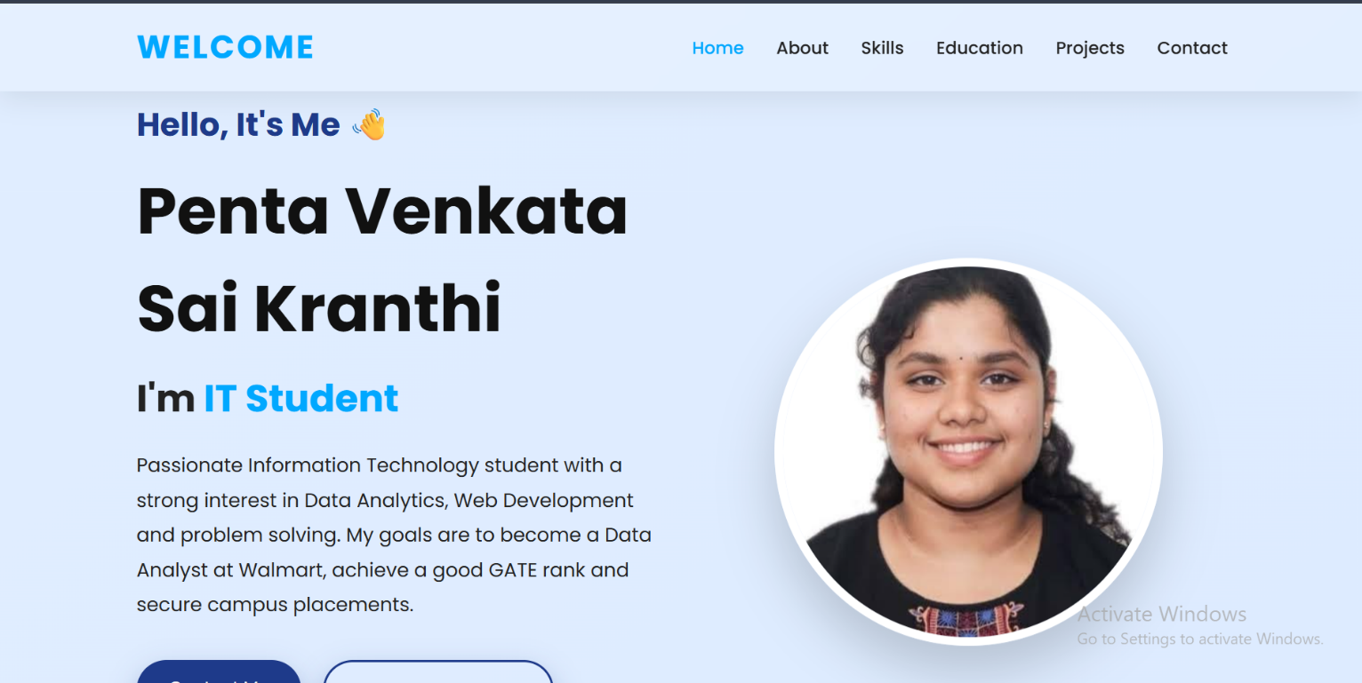

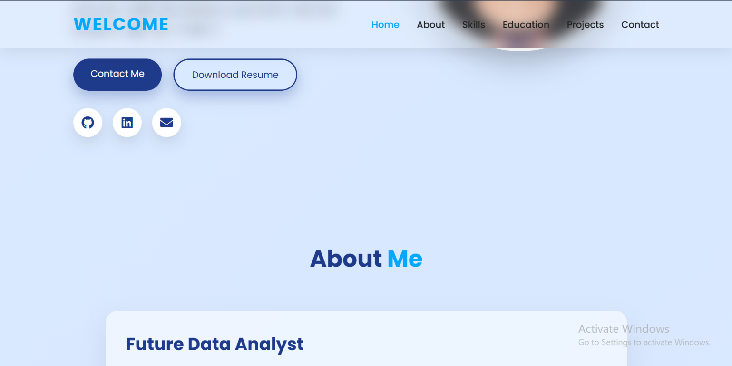

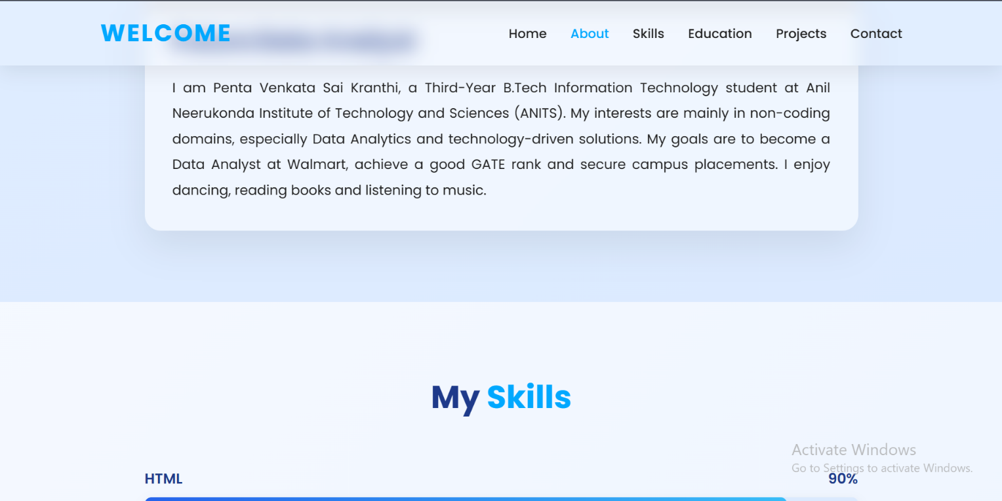
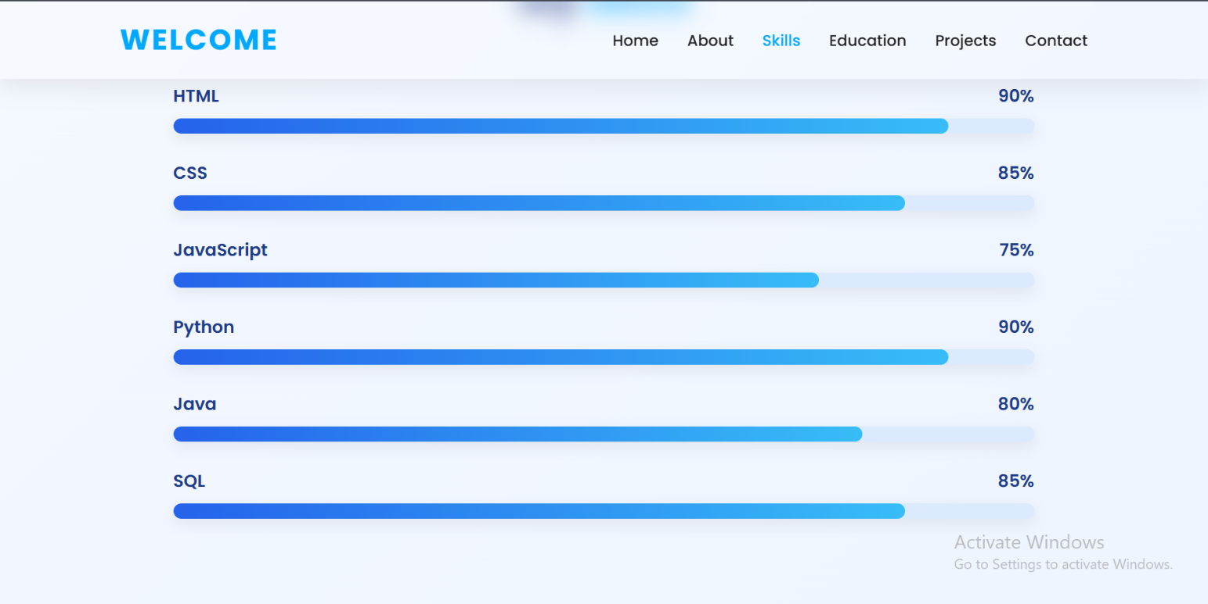

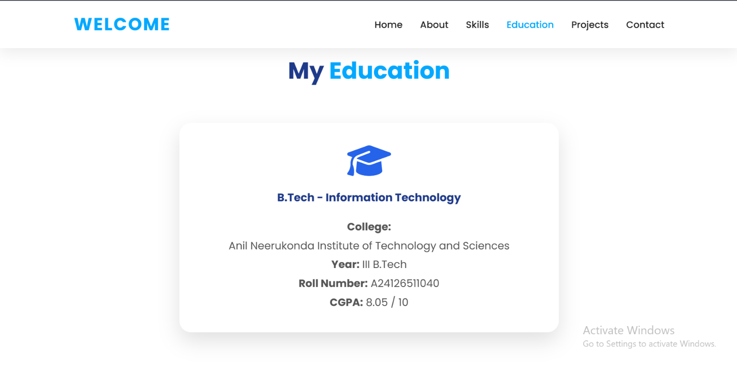
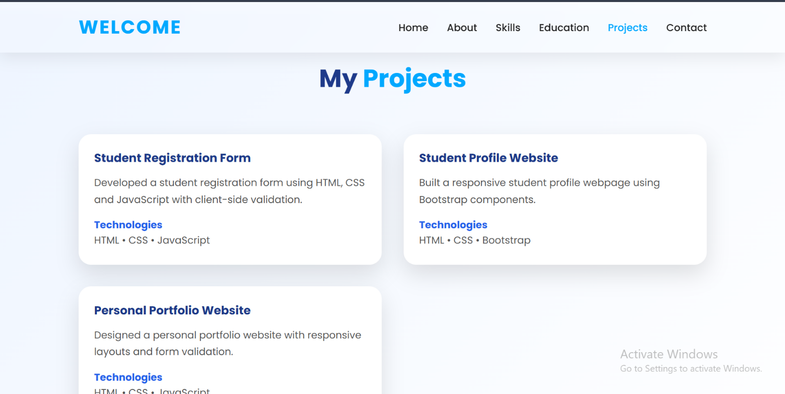
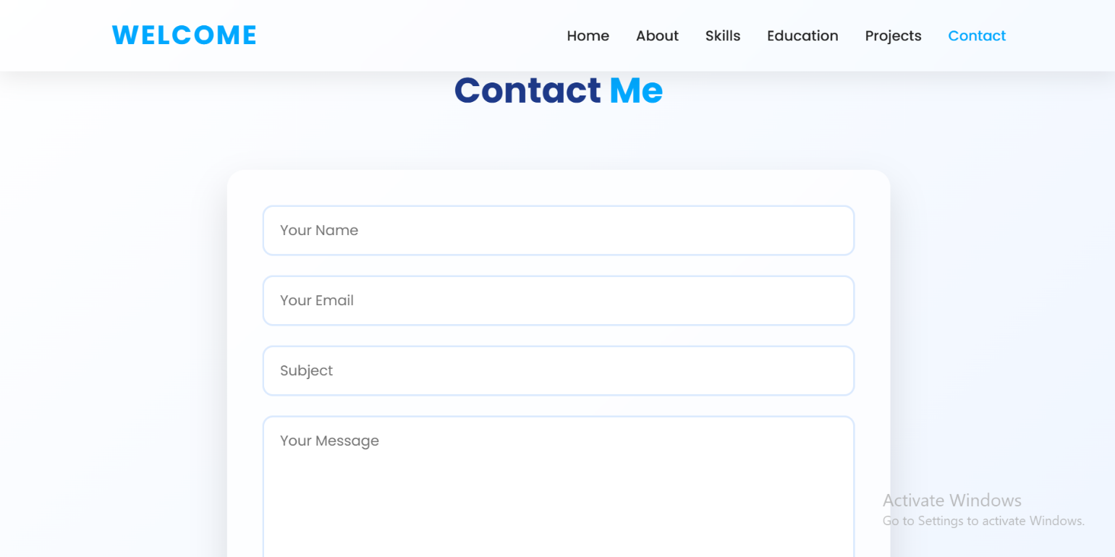
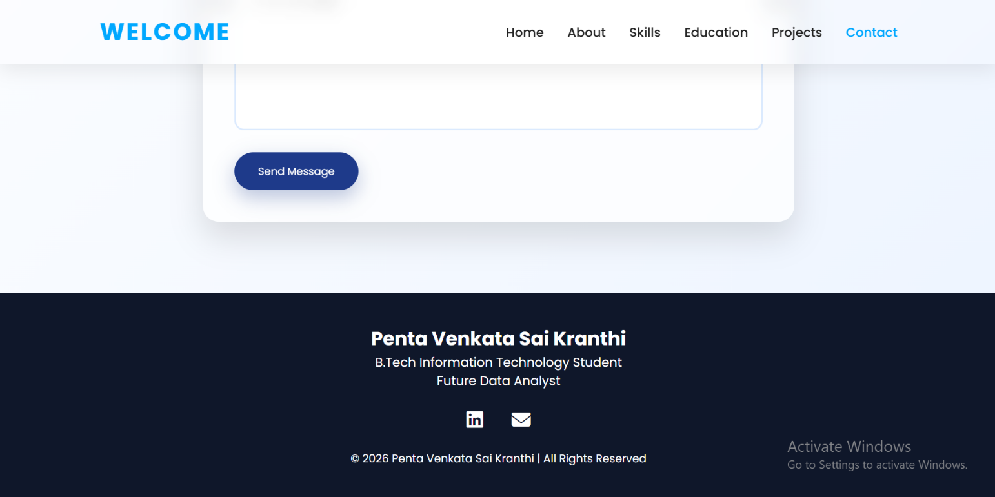
Outcome:-
The Personal Portfolio Website was successfully developed using HTML, CSS, and JavaScript. It provides a responsive layout with sections for personal information, skills, education, projects, and contact details. The contact form validates user inputs and displays appropriate error and success messages. This project improved understanding of responsive web design, CSS styling, JavaScript form validation, and user interaction.

